Admin Oracle Testing

**1. Sign In**

Action: Sign in page

Steps: Go to apex oracle.

Expected Results:Admins are directed to login page

Pass/Fail:Pass

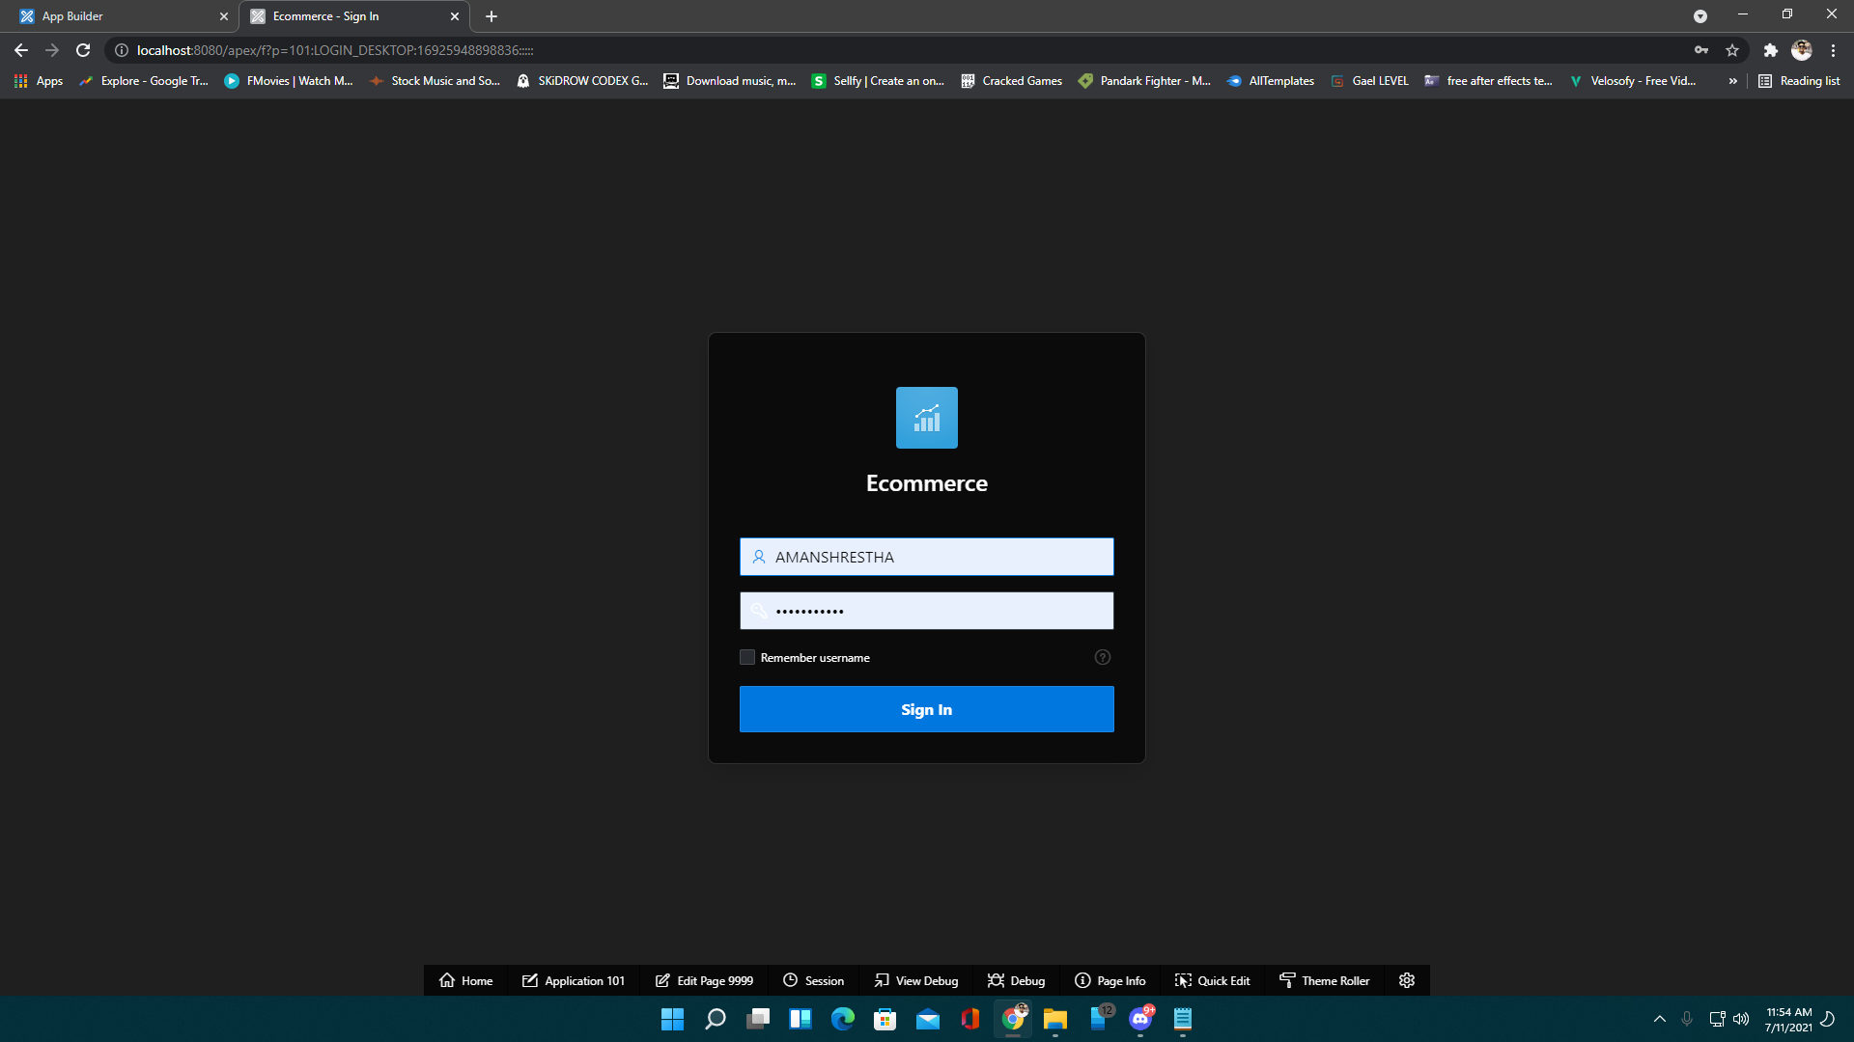

Action: Correct password and email

Steps: Fill the correct information in an appropriate box.

Expected Results:Goes into the dashboard

Pass/Fail:Pass

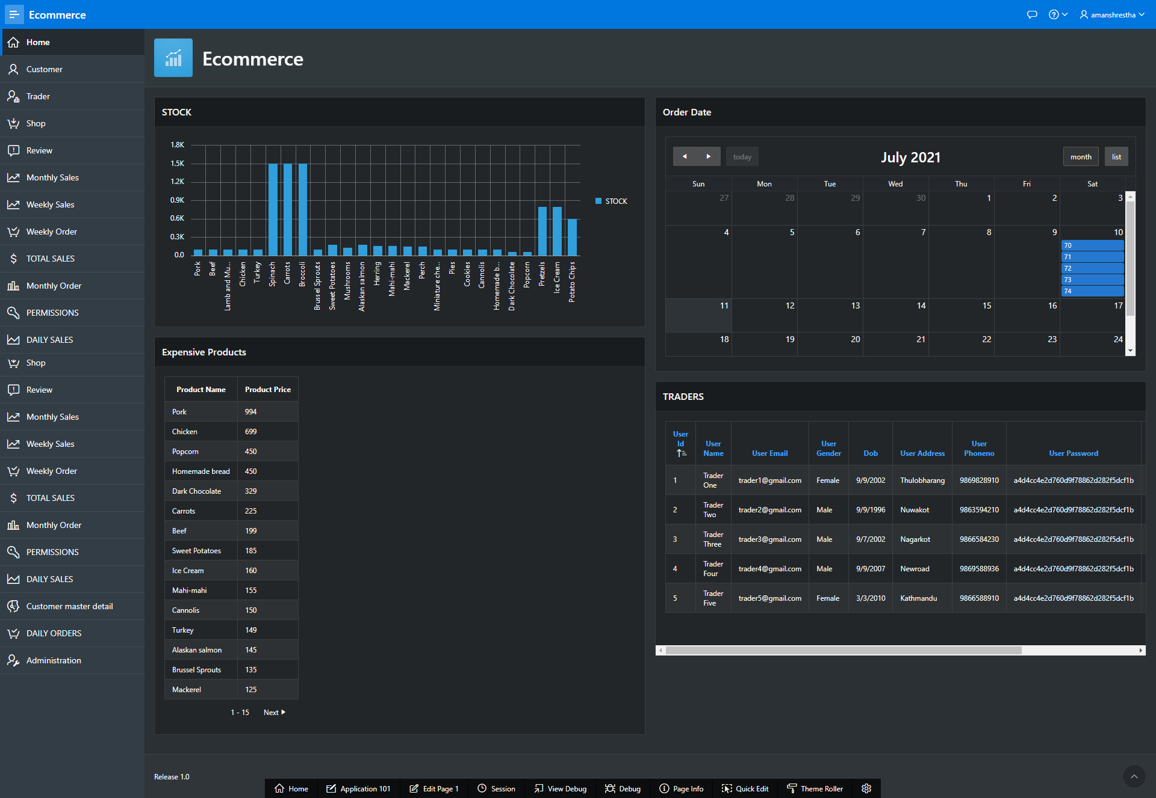

Action: If inserted incorrect password and Email

Steps:Fill the incorrect login credentials.

Expected Results: Error message is displayed

Pass/Fail:Pass

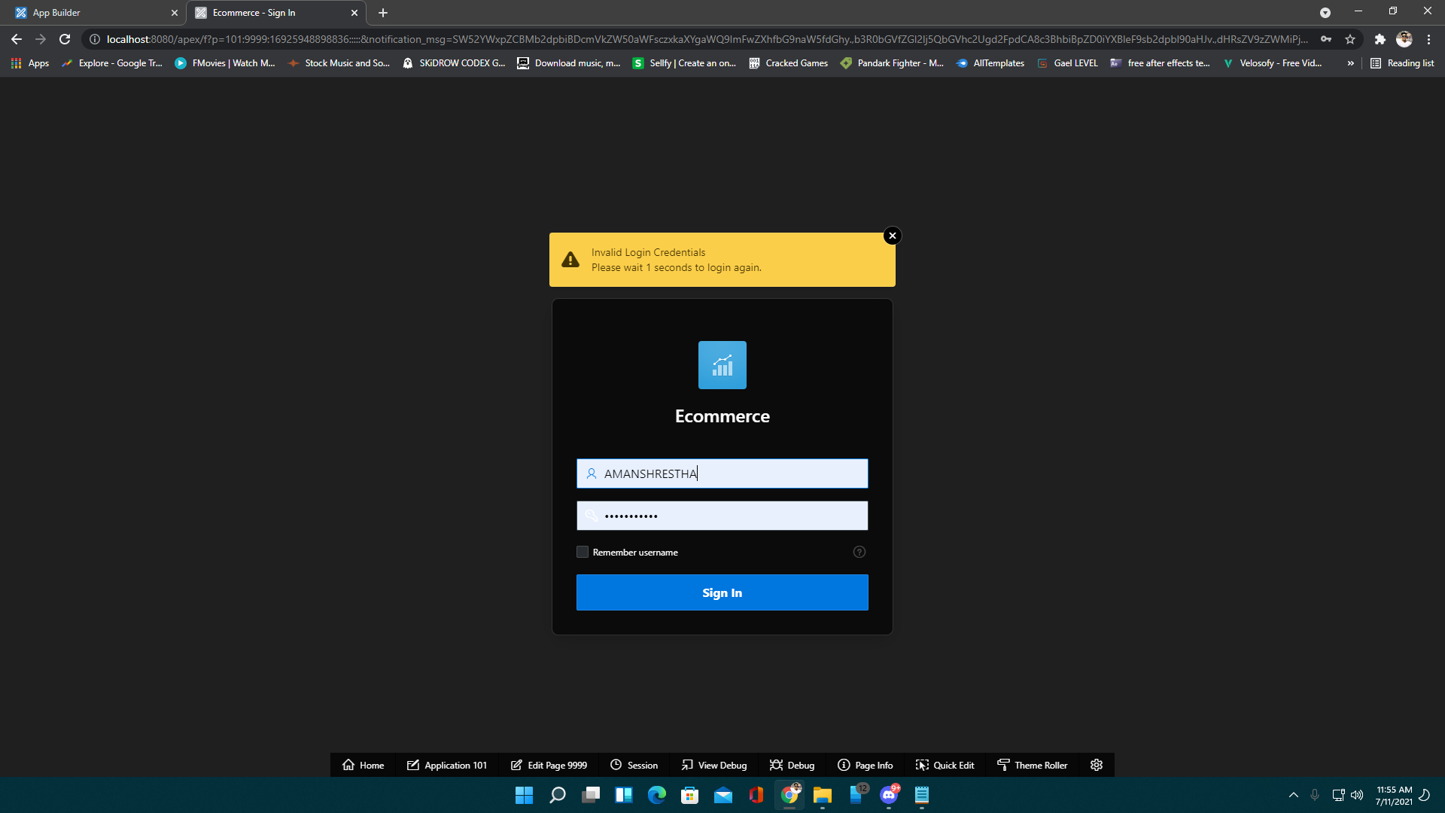

2. Dashboard

Action: View Customer

Steps: Click on Customer

Expected Results: You can view Customer’s data

Pass/Fail: Pass

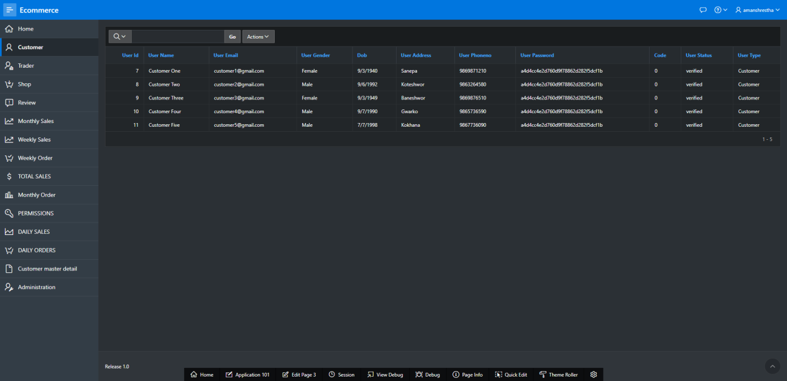

Action: View Trader

Steps: Click on Trader

Expected Results: Shows trader List.

Pass/Fail: Pass

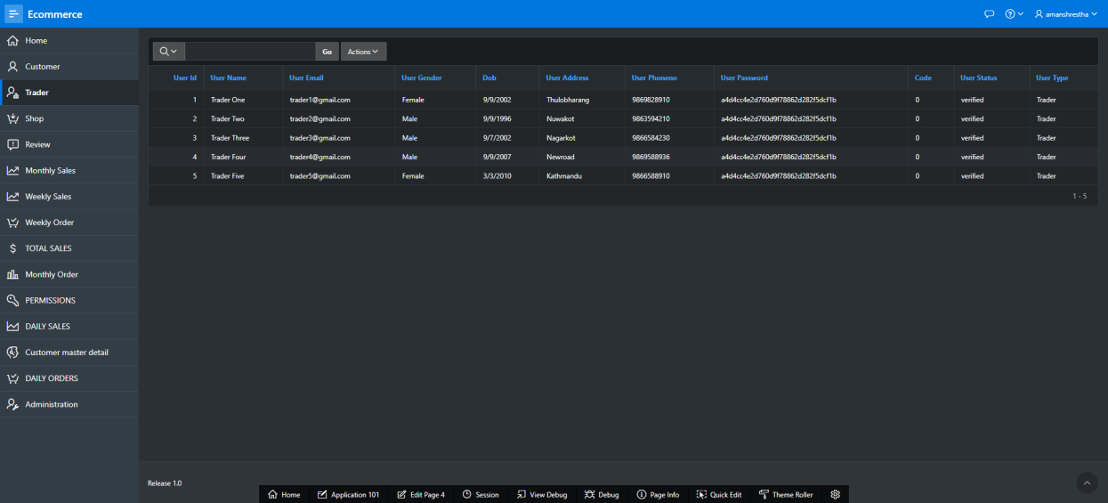

Action: View Shop

Steps: Click on Shop

Expected Results: Shows shop list.

Pass/Fail: Pass

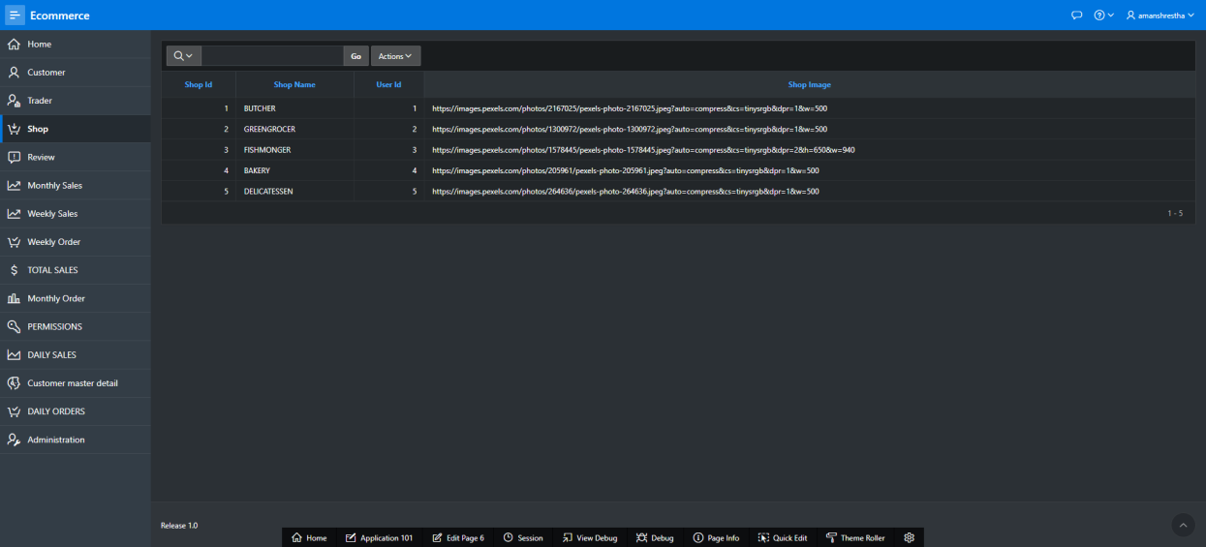

Action: View Review

Steps: Click Review

Expected Results: Shows Customer reviews

Pass/Fail:Pass

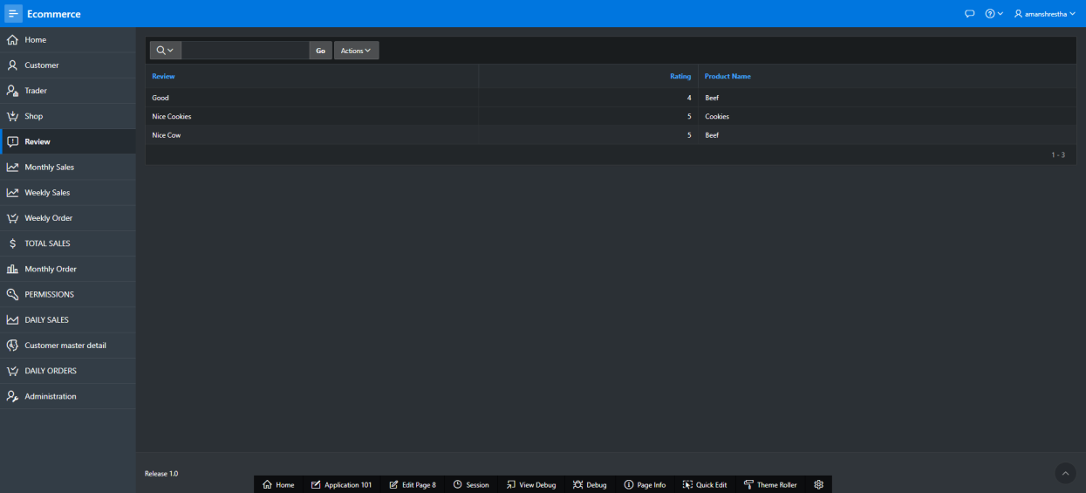

Action: View weekly sales

Steps: Click on Weekly Sales

Expected Results: Shows weekly sales of individual traders.

Pass/Fail:Pass

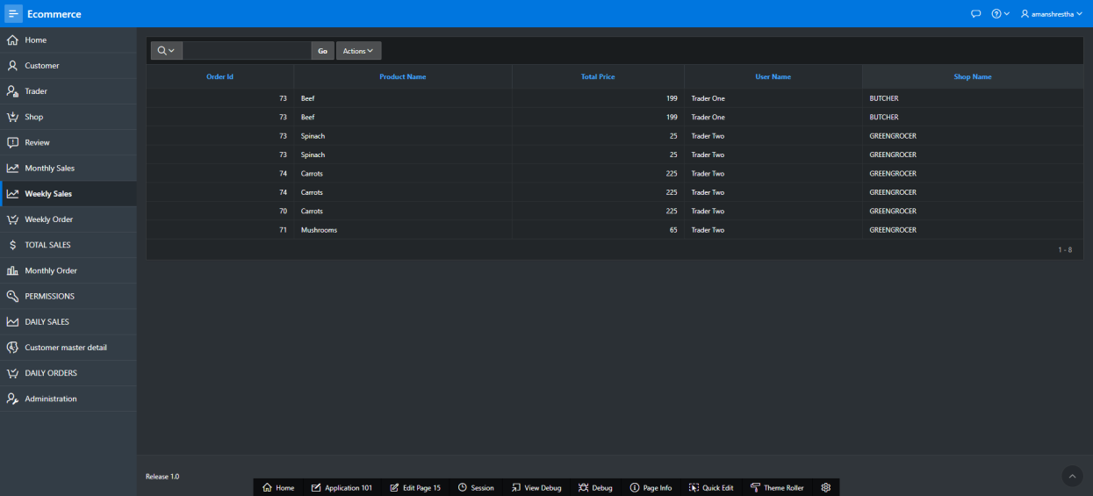

Action: View weekly order

Steps: Click on weekly order

Expected Results: Shows weekly order of individual traders.

Pass/Fail:Pass

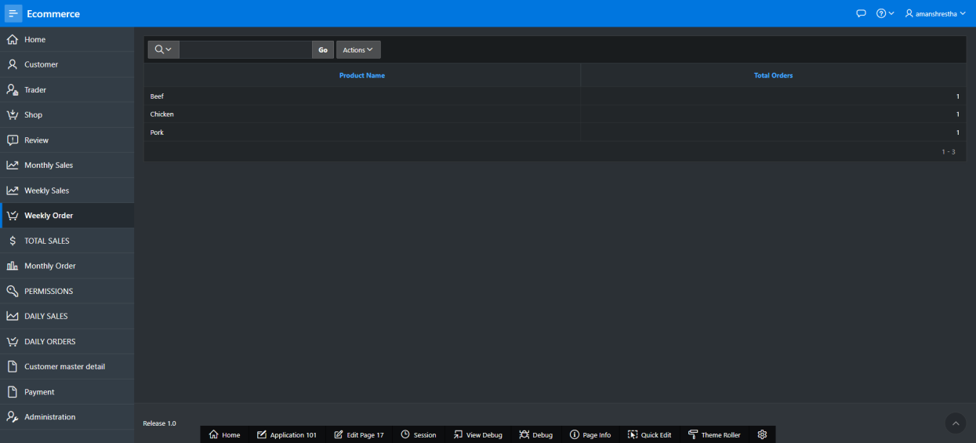

Action: View Total Sales

Steps:Click on total sales

Expected Results: Shows total sales of individual traders.

Pass/Fail: Pass

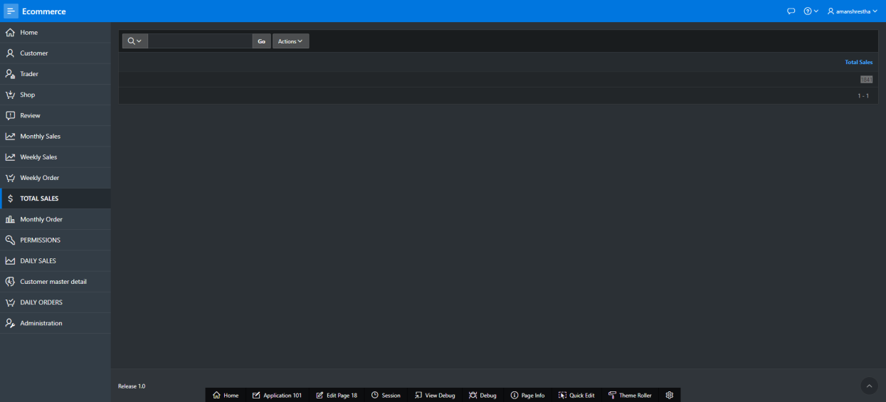

Action: View Monthly order

Steps: Click on monthly order

Expected Results:Shows monthly order of individual traders.

Pass/Fail: Pass

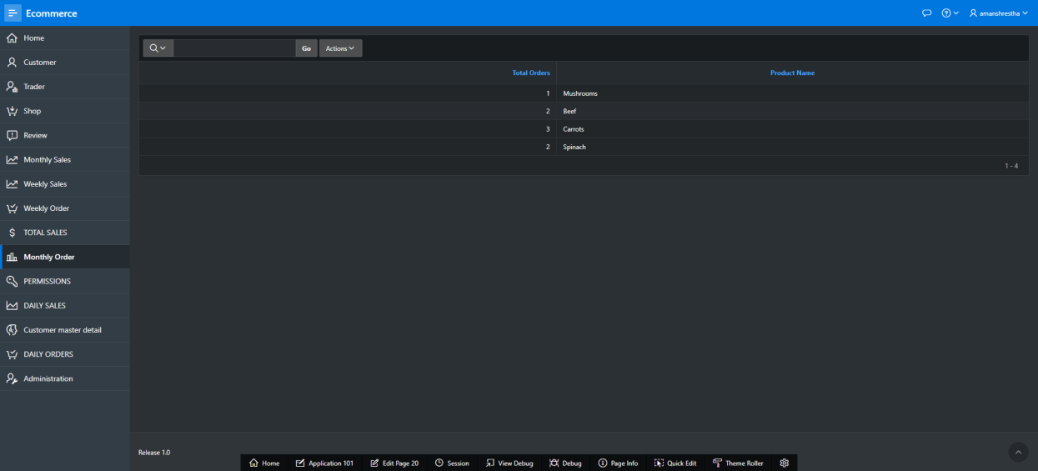

Action: View Daily Sales

Steps: Click on daily sales

Expected Results: Shows daily sales of individual traders.

Pass/Fail:Pass

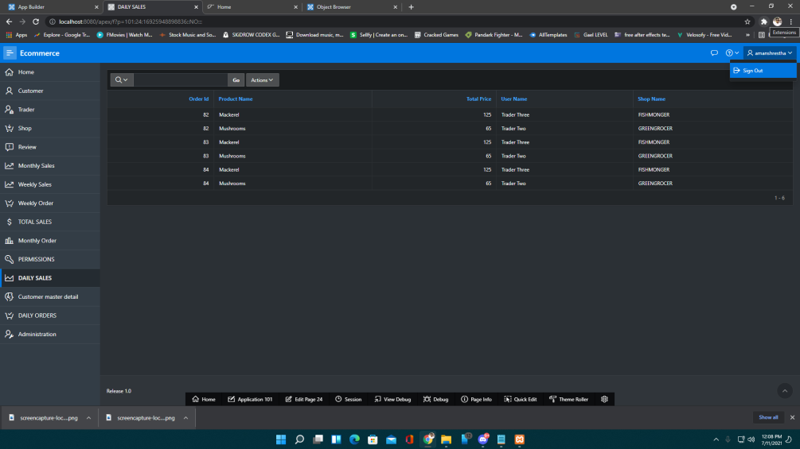

Action:View Daily Orders

Steps: Click on daily orders

Expected Results: Shows daily orders of individual traders.

Pass/Fail:Pass

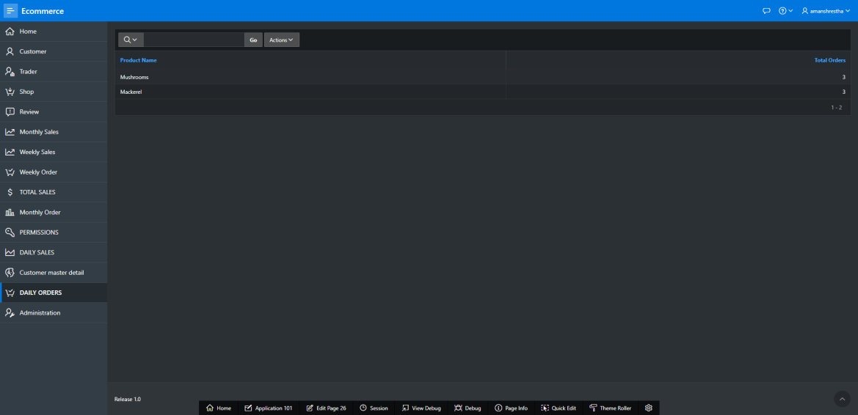

Action:View Customer master detail

Steps:Click on customer master detail

Expected Results: Shows customer master detail

Pass/Fail:Pass

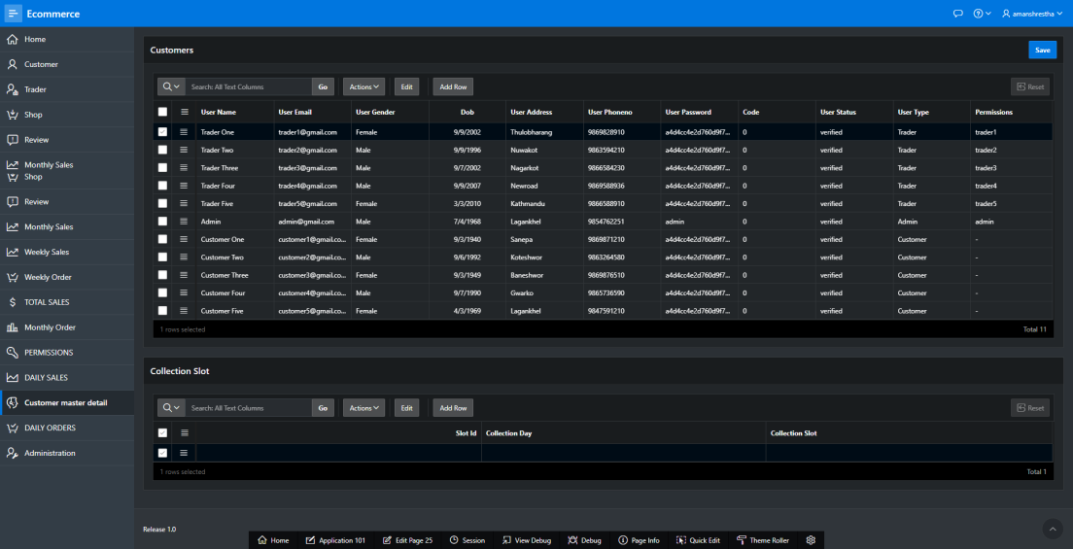

Action:Administration

Steps: Click on administration

Expected Results: Shows administration details

Pass/Fail:Pass

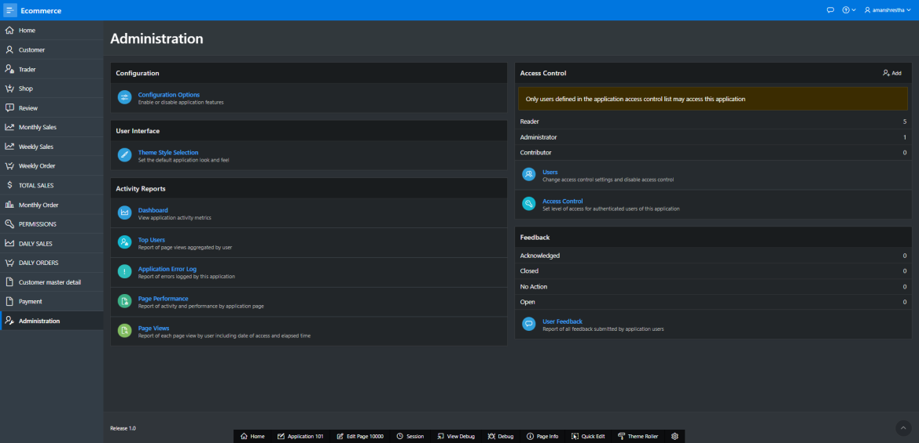

Action: Sign Out

Steps: Click on the logout button.

Expected Results: You can log out from the dashboard.

Pass/Fail: Fail

